Dear Parent/Guardian,
MEDIA STUDIES TOUR to PRAGUE 14-17 February 2019
We are excited to be proposing a school tour to Prague to support our curriculum plans for Media Studies pupils and enhance learning experiences within the school.
The visit will depart 14 February 2019 returning 17 February 2019, 4 days and 3 nights. The cost of the visit is £375.00 per pupil, which includes:
- Return flights
- Accommodation- Hotel Olsanka on a bed and breakfast basis
- Group travel insurance
- Overseas transfers
- Guided Visit to Barrandov Film Studios
- Guided Visit to Radio Free Europe
There are 20 places available for the visit and these will be allocated on a first come, first served basis. A reserve list will be created if necessary. There will also be three members of staff accompanying the learners.
In addition to the tour cost, we recommend that your child has spending money for the trip. They will also require a current passport.
To secure a place for your child on this trip, a non-refundable deposit of £125 is required, along with the completed permission slip by Friday 16th March. A further non-refundable payment of £125 is required by Friday 4th May, followed by a final payment of the remaining balance of £125 by Friday 7th December. Interim payments can be made between the dates outlined above.
Payments should be made using Parentpay, the school’s online payment website. If you have not activated your Parentpay account please email finance@birchwoodhigh.org to request an activation letter. You can also use this email to request a PayPoint letter. This will allow you to pay by cash at any PayPoint location in the local area. Please note you cannot pay by cash or cheque at the school office.
Learners must demonstrate and maintain a high standard of behaviour and a positive attitude to learning in lessons this school year to be allowed to attend this trip/residential. School reserves the right to withdraw your child’s place where they display poor or unsafe behaviour in school. If this is the case, any money already paid for the trip will not be refunded.
The trip is being booked through NST, the UK's leading educational travel company for schools. They work closely with us during the whole tour planning process to ensure that your child will get the very best learning experience whilst away.

If you have any queries, do not hesitate to contact me on shamilton@birchwoodhigh.org
Yours faithfully
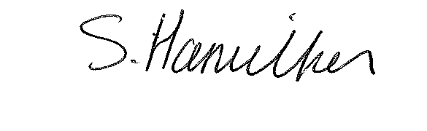
Mr Stuart Hamilton
Teacher of Media

……………………………………………………………………………………………………………

MEDIA STUDIES TOUR to PRAGUE 14-17 February 2019

I give permission for my child to attend the above trip. I have paid by £…………………Via Parent Pay

Name of Learner: ________________________________________________ Form: _______

Name of Parent/Carer: ________________________________________________________

Signature of Parent/Carer:________________________________________Date: __________

Emergency Contact Number: _______________________________________________________

Relevant Medical information ……………………………………………………………………………………………………………………
ST

